LAPORAN TUGAS 6
SISTEM OPERASI



Dosen Pengampu Mata Kuliah:
Triawan Adi Cahyanto, M.Kom

Disusun Oleh:
Suci Nur Hidayati (NIM 2410651023)

PRODI TEKNIK INFORMATIKA
FAKULTAS TEKNIK
UNIVERSITAS MUHAMMADIYAH JEMBER
2025

DAFTAR ISI
Disusun Oleh: 1
Tujuan Praktikum 3
Hasil Percobaan 3
Percobaan 1: Deadlock Sederhana 3
1.1 Penjelasan: 3
1.2 Kode: 3
1.3 Hasil percobaan 4
1.4 Analisis: 4
Percobaan 2: Deteksi Deadlock (Timeout) 4
2.1 Kode: 4
2.2 Hasil percobaan 5
2.3 Analisis: 5
Percobaan 3: Pencegahan Deadlock (Lock Ordering) 5
3.1. Kode: 5
3.2. Hasil percobaan 6
3.3 Analisis: 6
Percobaan 4: Try-Lock 6
4.1 Kode: 6
4.2. Hasil percobaan 7
4.3. Analisis: 8
Percobaan 5 : Banker's Algorithm 8
5.1. Kode Inti: 8
5.2Hasil percobaan 9
5.3. Analisis: 9
Kesimpulan 9

Tujuan Praktikum
Pada praktikum ini mahasiswa mempelajari mekanisme sinkronisasi dalam sistem operasi. Tujuan utamanya:
- Memahami cara kerja sinkronisasi antar-thread.
- Mengidentifikasi penyebab deadlock.
- Menganalisis teknik pencegahan dan deteksi deadlock.
- Mengamati pengaruh jumlah thread dan resource.
- Memahami penggunaan mutex, semaphore, dan try-lock.

Hasil Percobaan

Percobaan 1: Deadlock Sederhana

1.1 Penjelasan:
Dua thread saling mengambil dua mutex secara terbalik. Ini membuat circular wait dan menyebabkan deadlock.

1.2 Kode:
#include <stdio.h>
#include <pthread.h>
#include <unistd.h>

pthread_mutex_t lock1 = PTHREAD_MUTEX_INITIALIZER;
pthread_mutex_t lock2 = PTHREAD_MUTEX_INITIALIZER;

void* thread1_func(void* arg) {
printf("Thread 1: Mencoba mengambil Lock 1...\n");
pthread_mutex_lock(&lock1);
printf("Thread 1: Berhasil dapat Lock 1!\n");
sleep(1);

printf("Thread 1: Mencoba mengambil Lock 2...\n");
pthread_mutex_lock(&lock2);
printf("Thread 1: Berhasil dapat Lock 2!\n");

pthread_mutex_unlock(&lock2);
pthread_mutex_unlock(&lock1);
return NULL;
}

void* thread2_func(void* arg) {
printf("Thread 2: Mencoba mengambil Lock 2...\n");
pthread_mutex_lock(&lock2);
printf("Thread 2: Berhasil dapat Lock 2!\n");
sleep(1);

printf("Thread 2: Mencoba mengambil Lock 1...\n");
pthread_mutex_lock(&lock1);
printf("Thread 2: Berhasil dapat Lock 1!\n");

pthread_mutex_unlock(&lock1);
pthread_mutex_unlock(&lock2);
return NULL;
}

1.3 Hasil percobaan

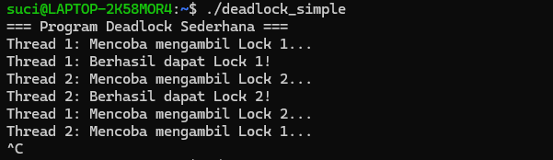

1.4 Analisis:
Deadlock terjadi karena:
- Hold and wait
- Circular wait
- No preemption
- Mutual exclusion

Percobaan 2: Deteksi Deadlock (Timeout)

2.1 Kode:
#include <stdio.h>
#include <pthread.h>
#include <unistd.h>
#include <time.h>

pthread_mutex_t lock1 = PTHREAD_MUTEX_INITIALIZER;
pthread_mutex_t lock2 = PTHREAD_MUTEX_INITIALIZER;

void* thread1_func(void* arg) {
struct timespec timeout;
int result;

pthread_mutex_lock(&lock1);
sleep(1);

clock_gettime(CLOCK_REALTIME, &timeout);
timeout.tv_sec += 2;

result = pthread_mutex_timedlock(&lock2, &timeout);
if (result != 0) {
printf("Thread 1: TIMEOUT! Deadlock terdeteksi.\n");
pthread_mutex_unlock(&lock1);
return NULL;
}

pthread_mutex_unlock(&lock2);
pthread_mutex_unlock(&lock1);
return NULL;
}

void* thread2_func(void* arg) {
pthread_mutex_lock(&lock2);
sleep(3);
pthread_mutex_unlock(&lock2);
return NULL;
}

2.2 Hasil percobaan
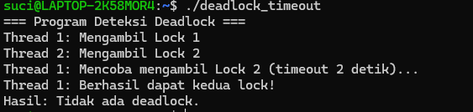

2.3 Analisis:
pthread_mutex_timedlock mencegah thread menunggu selamanya sehingga deadlock dapat terdeteksi.

Percobaan 3: Pencegahan Deadlock (Lock Ordering)

3.1. Kode:
#include <stdio.h>
#include <pthread.h>
#include <unistd.h>

pthread_mutex_t lock1 = PTHREAD_MUTEX_INITIALIZER;
pthread_mutex_t lock2 = PTHREAD_MUTEX_INITIALIZER;

void acquire_locks_in_order() {
pthread_mutex_lock(&lock1);
pthread_mutex_lock(&lock2);
}

void release_locks_in_order() {
pthread_mutex_unlock(&lock2);
pthread_mutex_unlock(&lock1);
}

void* thread1_func(void* arg) {
acquire_locks_in_order();
sleep(1);
release_locks_in_order();
return NULL;
}

void* thread2_func(void* arg) {
acquire_locks_in_order();
sleep(1);
release_locks_in_order();
return NULL;
}

3.2. Hasil percobaan
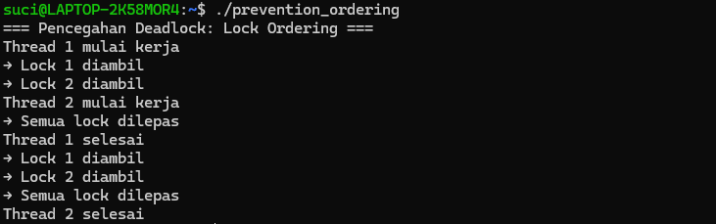

3.3 Analisis:
Lock ordering menghilangkan circular wait → deadlock tidak bisa terjadi

Percobaan 4: Try-Lock

4.1 Kode:
#include <stdio.h>
#include <pthread.h>
#include <unistd.h>

pthread_mutex_t lock1 = PTHREAD_MUTEX_INITIALIZER;
pthread_mutex_t lock2 = PTHREAD_MUTEX_INITIALIZER;

void* thread1_func(void* arg) {
while (1) {
pthread_mutex_lock(&lock1);
if (pthread_mutex_trylock(&lock2) == 0) {
sleep(1);
pthread_mutex_unlock(&lock2);
pthread_mutex_unlock(&lock1);
break;
} else {
pthread_mutex_unlock(&lock1);
usleep(100000);
}
}
return NULL;
}

void* thread2_func(void* arg) {
while (1) {
pthread_mutex_lock(&lock2);
if (pthread_mutex_trylock(&lock1) == 0) {
sleep(1);
pthread_mutex_unlock(&lock1);
pthread_mutex_unlock(&lock2);
break;
} else {
pthread_mutex_unlock(&lock2);
usleep(150000);
}
}
return NULL;
}

4.2. Hasil percobaan

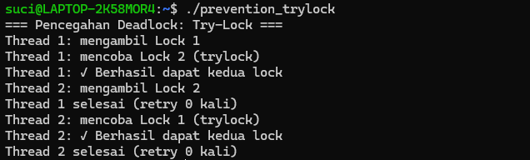

4.3. Analisis:
Try-lock mencegah hold and wait sehingga deadlock tidak terjadi

Percobaan 5 : Banker's Algorithm

5.1. Kode Inti:
#include <stdio.h>
#include <stdbool.h>

#define P 5
#define R 3

int available[R] = {3, 3, 2};

int maximum[P][R] = {
{7, 5, 3},
{3, 2, 2},
{9, 0, 2},
{2, 2, 2},
{4, 3, 3}
};

int allocation[P][R] = {
{0, 1, 0},
{2, 0, 0},
{3, 0, 2},
{2, 1, 1},
{0, 0, 2}
};

int need[P][R];

void calculate_need() {
for (int i = 0; i < P; i++)
for (int j = 0; j < R; j++)
need[i][j] = maximum[i][j] - allocation[i][j];
}

5.2Hasil percobaan

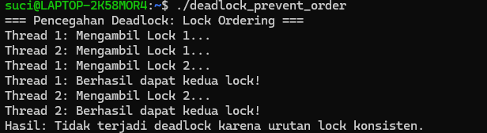

5.3. Analisis:
Banker memastikan resource hanya diberikan jika sistem tetap dalam kondisi safe state, sehingga deadlock tidak mungkin terjadi.

Kesimpulan
- Sinkronisasi mencegah race condition.
- Deadlock terjadi jika circular wait + hold and wait + no preemption.
- Mutex = akses eksklusif, semaphore = counting resource.
- Tanpa sinkronisasi, program paralel menjadi macet dan tidak konsisten.

